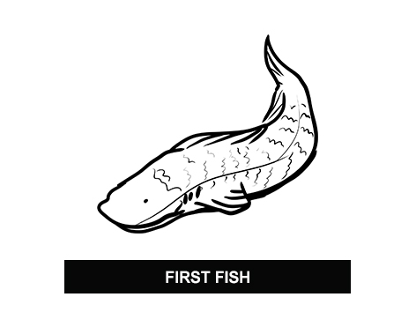
Activity sheet 2.1 – Key event cards

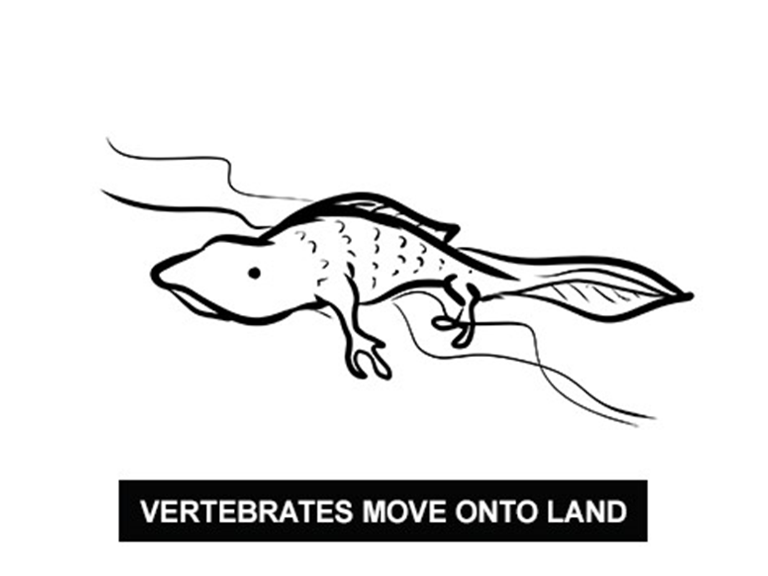

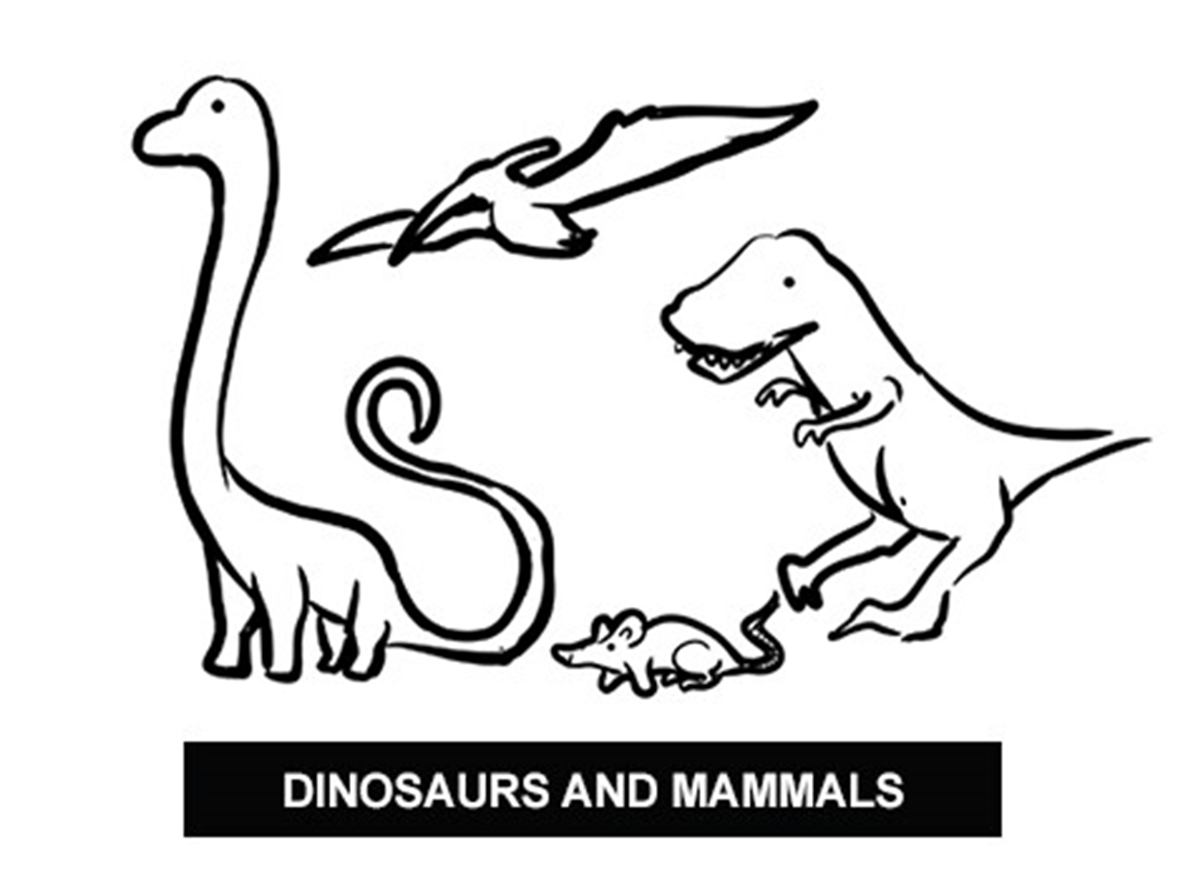

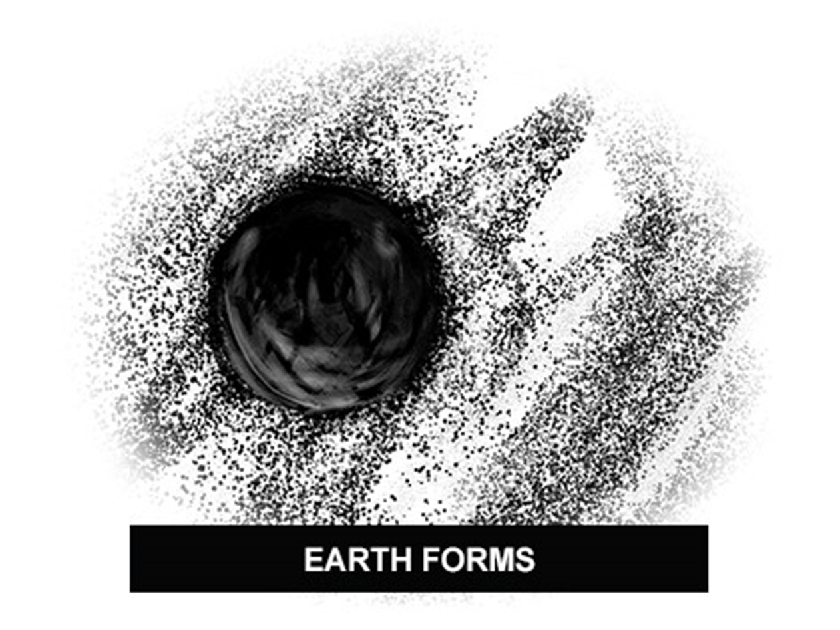

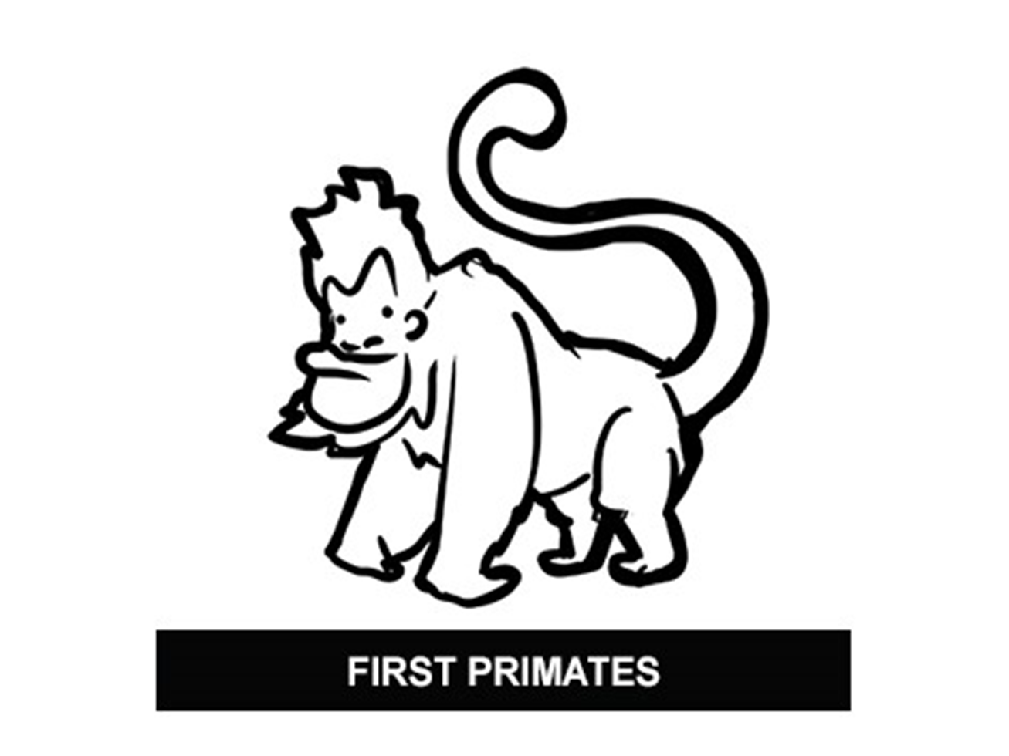

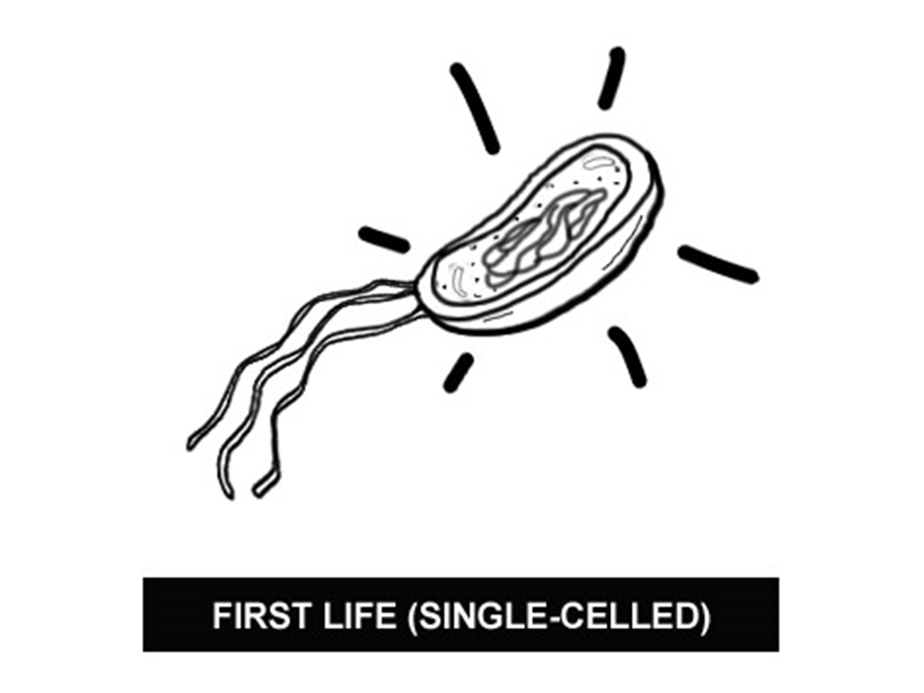

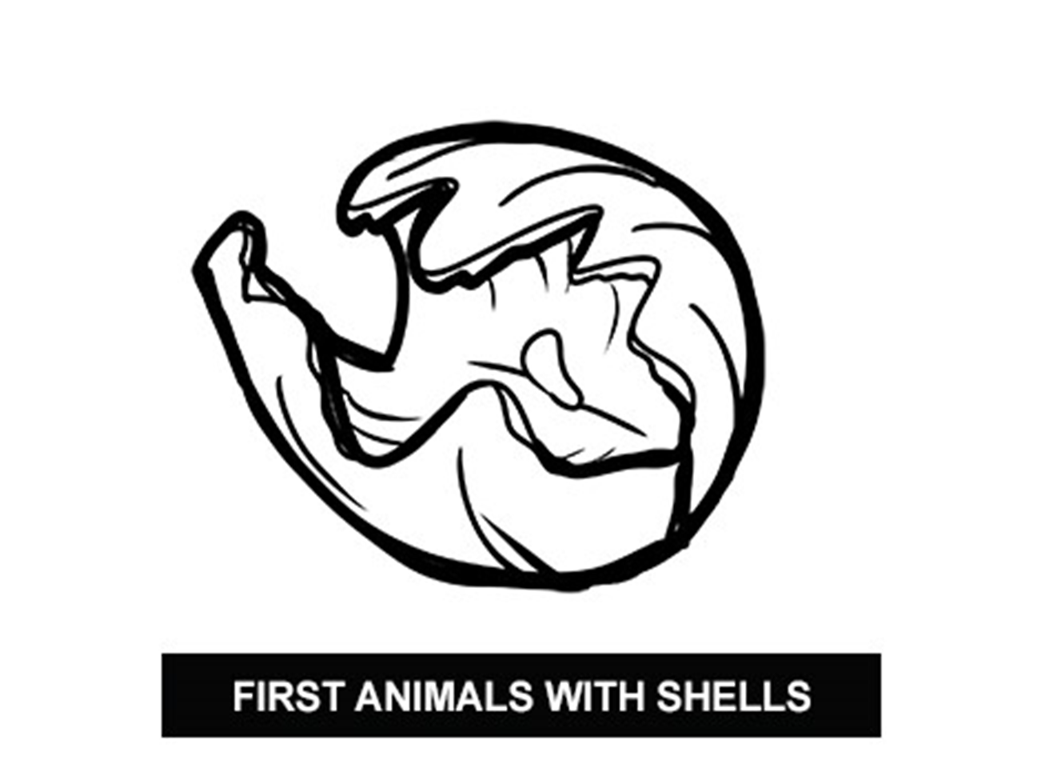

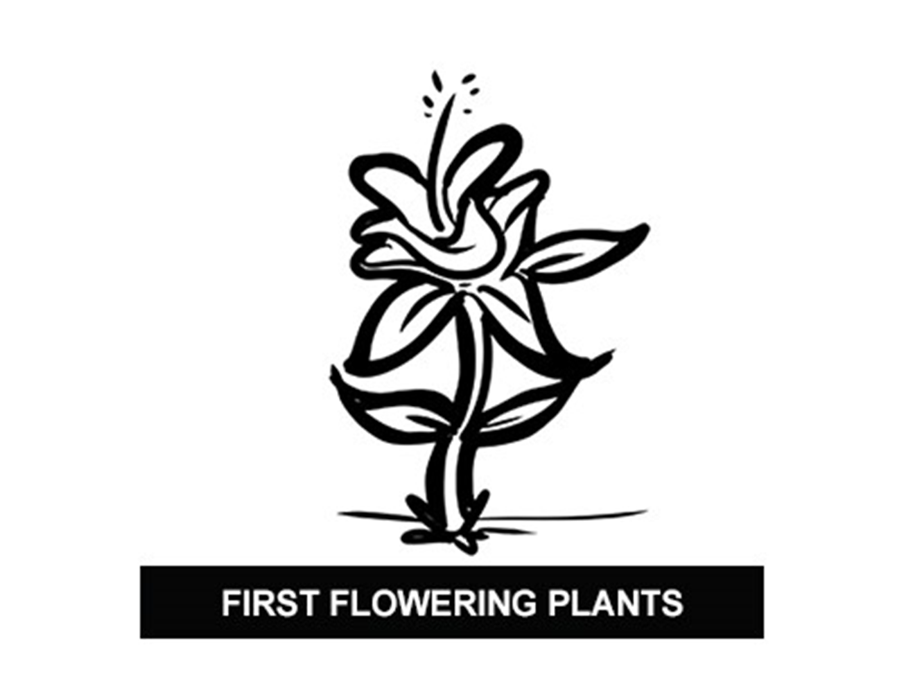

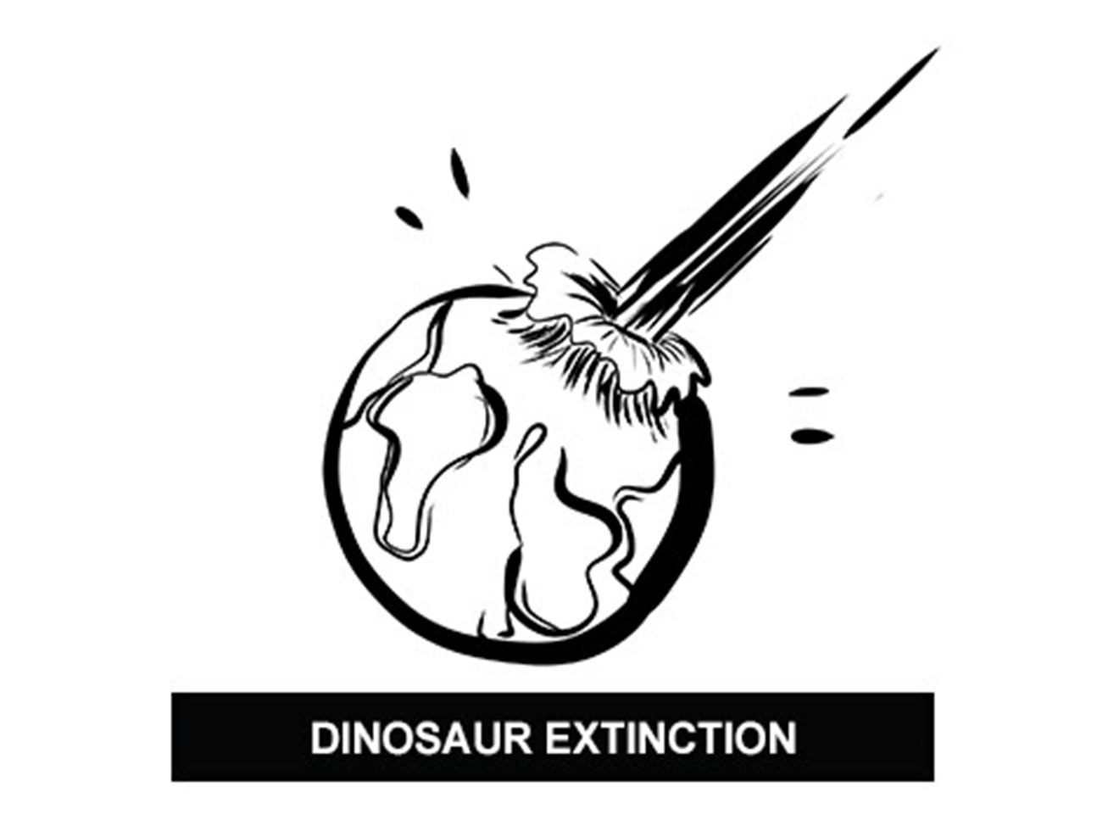

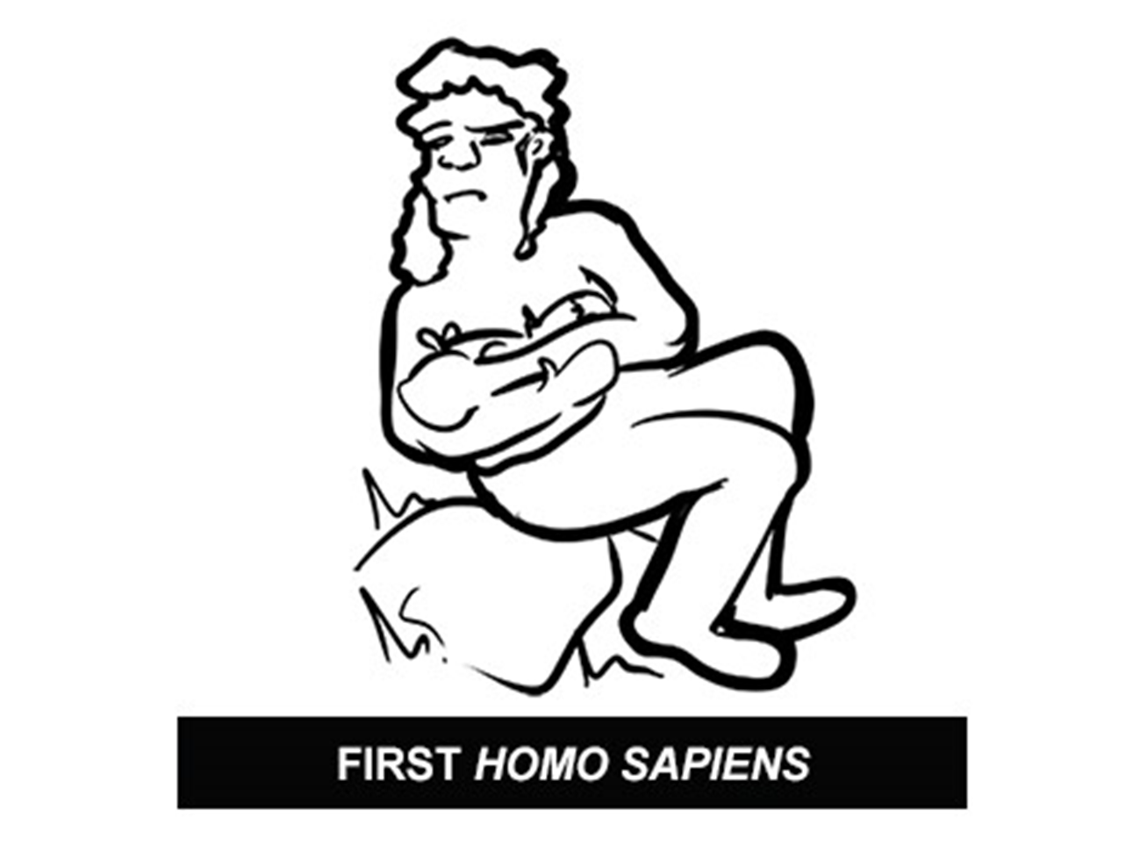

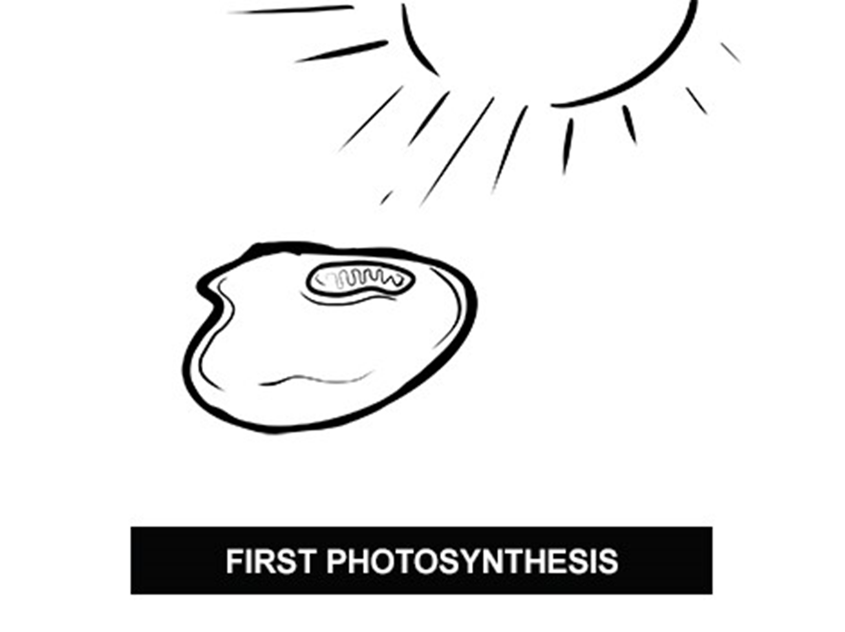

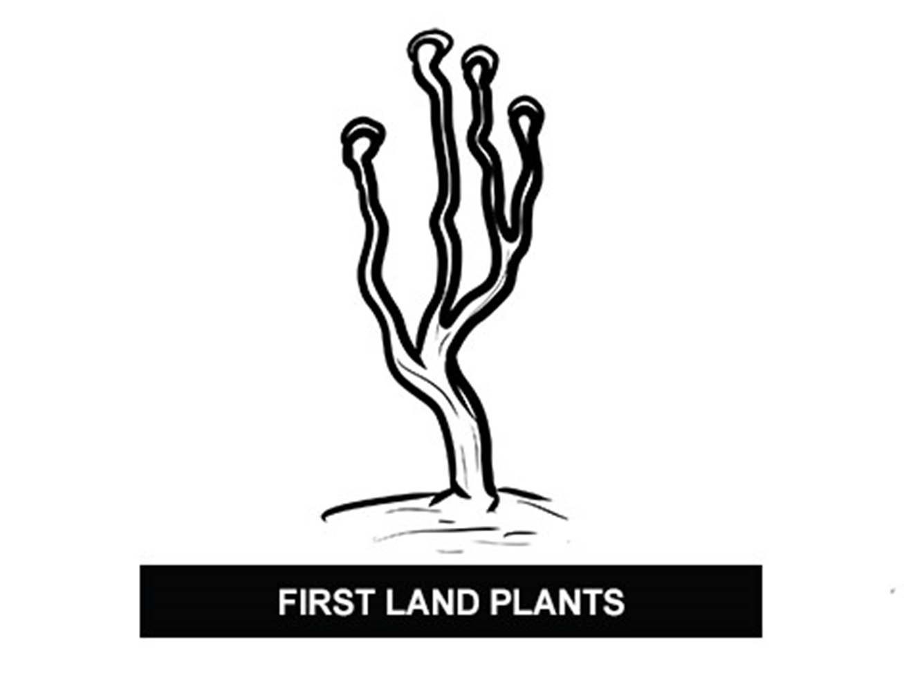

Table of key events in the evolution of life
Event | Time (million years ago) | Toilet paper sheet number (1 sheet = 20 million years)
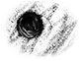Earth forms | 4600 | 230
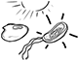First life (single-celled) and photosynthesis | 3500 | 175
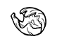First animals with shells | 545 | 27
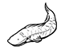First fish | 530 | 27
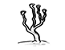First land plants | 420 | 21
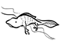Vertebrates move onto land | 360 | 18
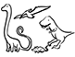Dinosaurs and mammals | 225 | 11
First flowering plants | 140 | 7
Dinosaur extinction | 65 | 3
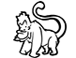First primates | 55 | 3
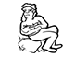First humans | 0.2 | 1 (top edge)

